MongoDb Assignment-1

1.Insert Documents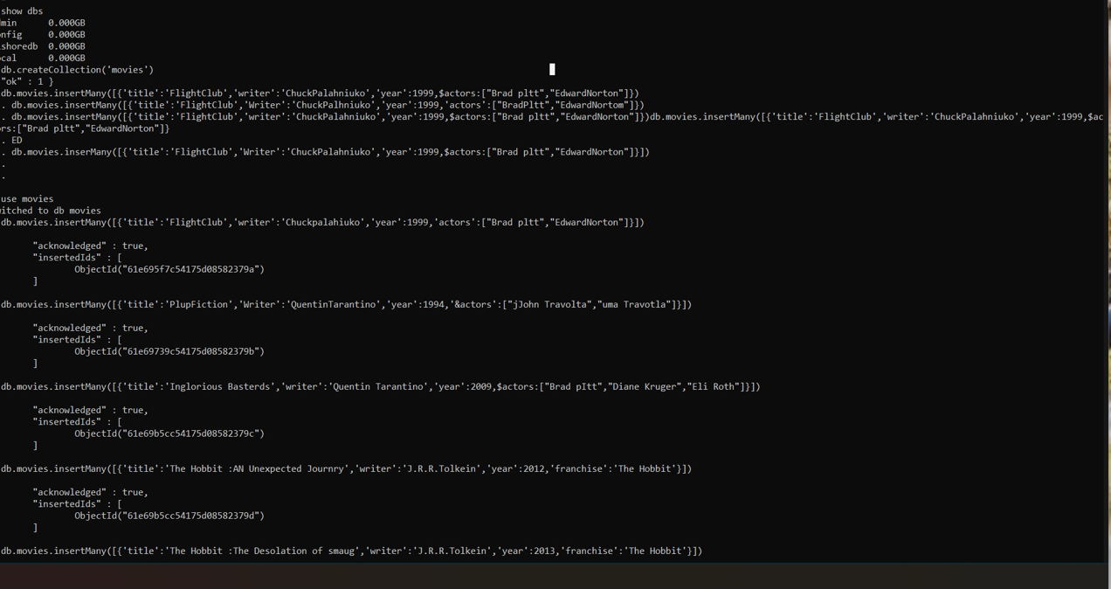

2.Query/Find Documents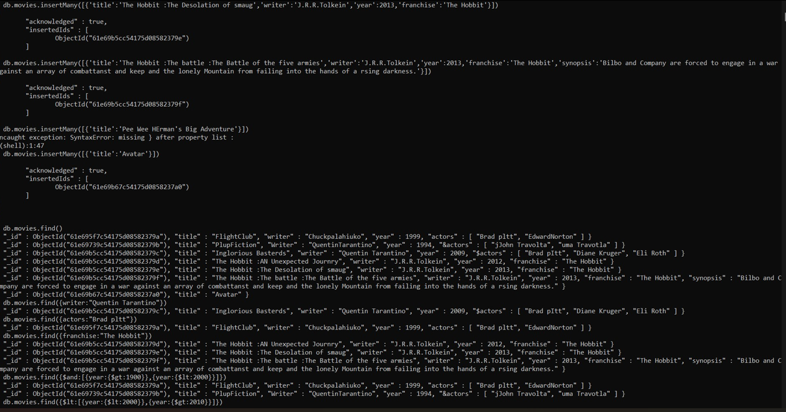

3.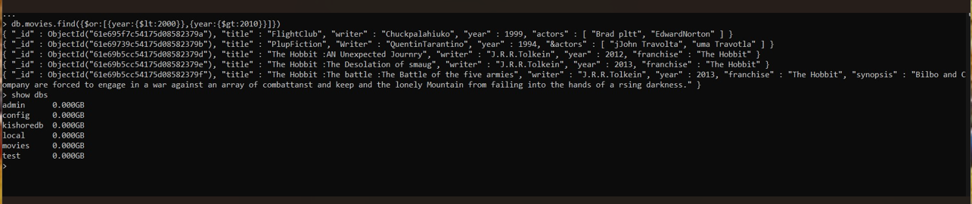4 Update Documents

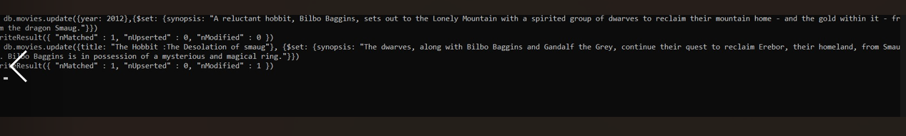

5.Text Search /Delete documents/Relationships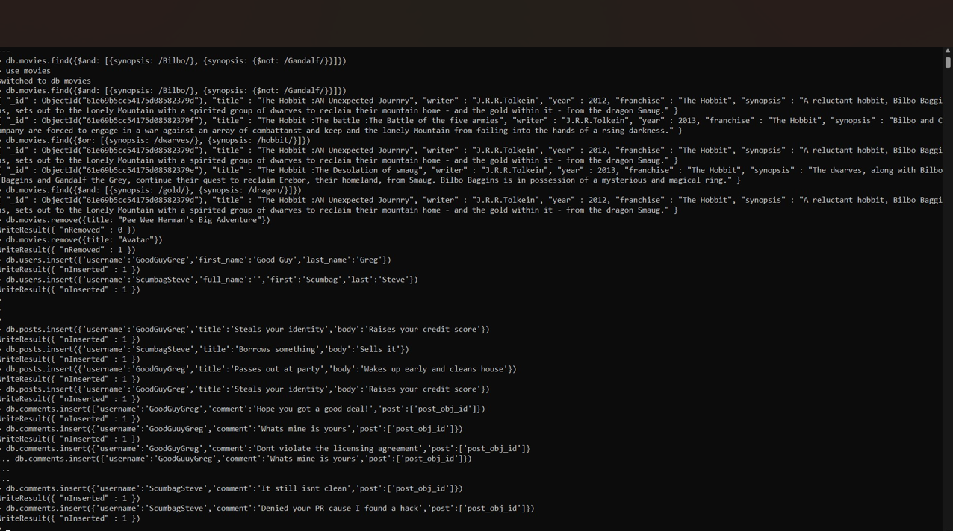

6.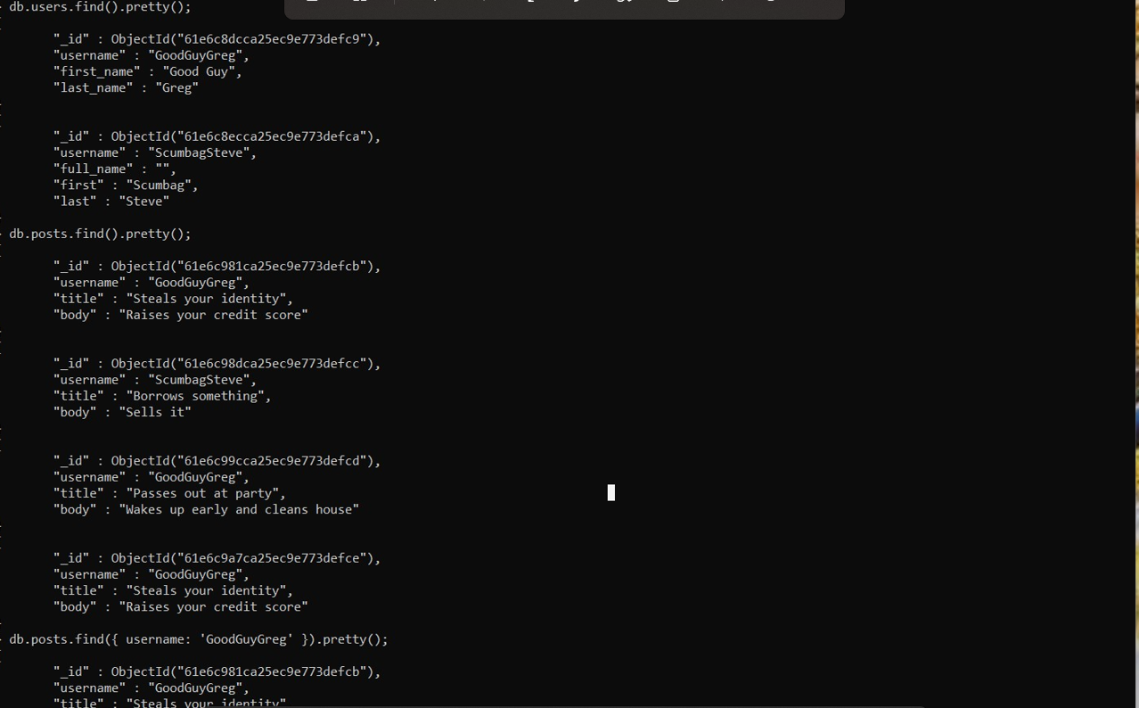

7.Relationships /Querying Related Collections

8.

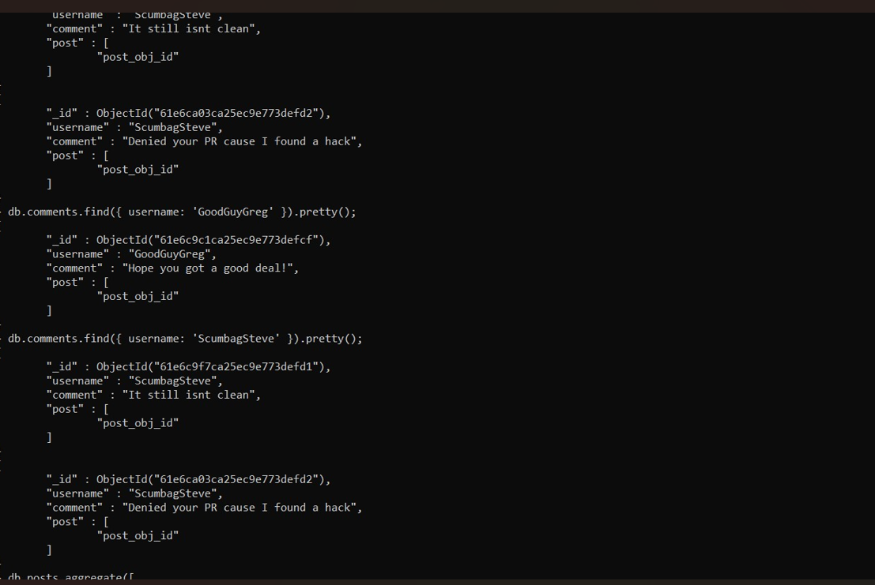

Atlanta population:

1.

